PO Box 9060, Hickory, NC 28603 (828)469-7441 CatawbaValleyGALA@gmail.com www.cvgal.org

**2024 Tami Barker Scholarship Awards**

The Catawba Valley Guardian ad Litem Association will award three $2,000 scholarships to three deserving youth in the foster care system of District 36 who will be attending an accredited trade or vocational school, community college or four year university. This scholarship is for 2024, but the applicants may apply again in subsequent years. The application deadline is June 15, 2024 and scholarship winners will be announced on June 30, 2024. Scholarship monies will be paid directly to the educational institution by June 30, 2024.

**ELIGIBILITY**:

1. Applicants must be enrolled in a full-time program at an accredited university, community college, or trade/vocational institution.
2. Applicants must be aging out of the foster care s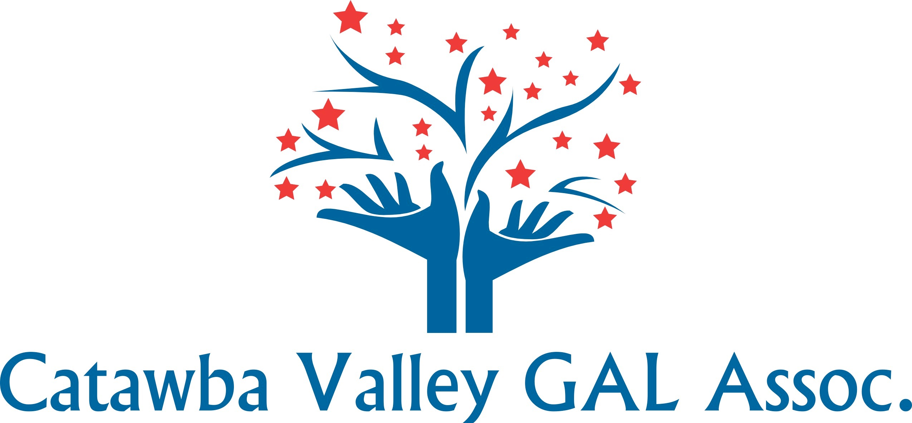ystem at 18 years of age and be signing a CARS agreement with DSS.

**APPLICATION REQUIREMENTS**:

1. Complete the attached application form
2. Attach one letter of recommendation from someone other than a relative. Possible choices are DSS worker, Guardian ad Litem, foster parent, employer, teacher or counselor.
3. A copy of your most recent report card including cumulative GPA
4. A personal statement of less than 500 words explaining why you feel you should receive this scholarship and what your goals for the future will entail.

**SUBMISSION OF APPLICATION**:

The completed application along with recommendation letter, personal statement, and report card should be mailed to the address above or scanned and emailed by the deadline of June 15.

CVGALA is a 501-c-3 nonprofit organization advocating for abused and neglected children in Burke, Caldwell & Catawba Counties since 2013~

**2024 GUARDIAN AD LITEM SCHOLARSHIP**

Name of Applicant ___________________________________________________________

Email__________________________________ Telephone ___________________________

Current Address _____________________________________________________________

Current High School, or College_________________________________________________

Graduation Date_____________________________ GPA __________(attach copy)

List extracurricular activities or sports during high school or college:____________________

___________________________________________________________________________

___________________________________________________________________________

List any employment history including company name and time employed:__________________________________________________________________

___________________________________________________________________________

Community Activities or Honors received: _________________________________________

___________________________________________________________________________

College, University or Vocational School you will attend in the fall:

____________________________________________________________________________

Major:____________________________Anticipated graduation________________________

Have you applied or been awarded funding through NC REACH? ______________________

I, __________________________________(signature) pledge that the information contained in this application is true and accurate to the best of my ability. I understand that false statements will disqualify me from receiving this award.

***Please send completed application along with one **letter of recommendation**, a **personal statement**, and **copy of current grades** to the address by email to [CatawbaValleyGALA@gmail com](mailto:CatawbaValleyGALA@gmail.com).